Dimensions in mm
ICS 13.110 Supersedes
SN 401-4 : 2010-03

Table of contents
Page
- Scope 1
- Principles 1
- Door interlocking system Schmersal AZM 415 2
Handle system AZM 415 3
Door position detection 3
Installation example of the electric door interlocking system Schmersal AZM 415 4
- Key transfer system DOLD STS 6
Assemblies of key transfer system DOLD-STS 6
DOLD-STS switching principle 8
Installation example of key transfer system DOLD-STS 8
Referenced technical standards, codes and regulations 10
Annex A (normative) 10
Door interlocking system Schmersal AZM 415 10
Key transfer system DOLD STS - overview of assemblies 11
Key transfer system DOLD STS – structure and dimensional diagrams 12

- Scope
This standard specifies electric door interlocking for fence systems of safety class TII according to SN 401-1 in NIHVA.
The door interlocks shall be provided at the door elements of the types TERE and TELE according to SN 401-3.

- Principles
Doors of safety category TII shall be provided with the electric components specified in this standard. These components shall be ordered in addition to the door units according to SN 401-3.

They shall be used as specified in part 1 of the document "Zertifizierung von Schutzmaßnahmen“ (certification of protective measures).

Irrespective of the key system used, open doors can be secured with a U-lock to prevent locking by inadvertence. This mechanical device is specified in SN 401-3 and provided on every safety door.

Unlocking for escape from the danger zone shall always be provided when at least one of the following conditions is fulfilled.

- There is no place inside the danger zone in which persons can stay safe till the door opens.
This situation may also make it necessary to provide a second escape route. Reasons for such necessity may be hazards from gas or liquids (CO, CO2, emulsion mist, vapour etc.), danger from heat, small space etc.
- Provision of escape unlocking is expressly stipulated in one of the standards to be applied (e.g. cooling chamber doors).
- The danger zone is so large and difficult to survey that there is the risk of failure to notice a person in this area when the door is closed and inside the area there is no way to contact a person outside the area at a workplace which is usually occupied (control pulpit etc.).

Access to the danger zone shall be possible only upon intentional actuation of a door latch or by means of a key. To achieve the Performance Level PL according to DIN EN ISO 13849-1, a connected safety-related control system (evaluation) is always required.
There is a choice between an electric door interlocking system and a key transfer system. In the Department of Plant Engineering and Hardware Design corresponding typicals are available for these configurations.
They have been tested and shall be used as specified.

- Door interlocking system Schmersal AZM 415
To achieve the max. performance level PL d, every door shall be provided with the electric door interlocking system Schmersal AZM 415. Table 1 lists the components of the electric door interlocking system AZM 415. The SAP material numbers are indicated in Table A.1 in Annex A (informative).It is important to note that only the variant for installation at the inner side of the door shall be used. Figure 1 shows the view of the door from a perspective inside the danger zone. Figure 2 illustrates this variant again. The basic circuit diagram is shown in figure 3.

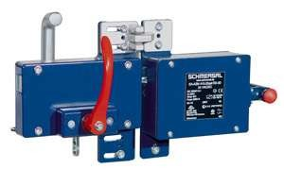Handle
Door snap
TFI-010
Guard lock
AZM 415-02/11zpkTEI-24VAC/DC
AZM 415-STS30-01

Fig. 1 - Schmersal, AZM 415

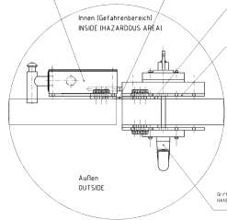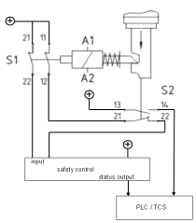
Guard lock
AZM 415-02/11zpkTEI-24VAC/DC
Door snap
TFI-010
Base plate
for handle system
Mounting plate for handle system MP
Handle system
AZM 415-STS30-01

Fig. 2- AZM 415, top view Fig. 3 – Basic circuit diagram AZM 415

Table 1- Components of AZM 415

Quantity | Designation | Manufacturer's item number
1 | Guard lock | AZM 415-02/11zpkTEI-24VAC/DC
1 | Handle system (right-hinged) | AZM 415-STS30-01
1 | Handle system (left-hinged) | AZM 415-STS30-02
1 | Door snap | TFI-010
1 | Mounting plate | MP
1 | Male triangular wrench a) | M5
a) Male triangular wrench for auxiliary unlocking from outside

Handle system AZM 415
Handle systems for the electric guard lock AZM 415 are available in 2 types. For wing door units according to SN 401-3, FTR (right-hinged, opening outwards), the system AZM 415-STS30-01 (Fig. 4) is used, for wing door units FTL (left-hinged, open- ing outwards), the system AZM 415-STS30-02 (Fig. 5). Both types are equipped with actuators for locking magnet and panic handle, installation is on the inside.

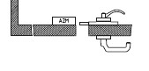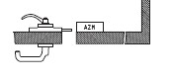

Fig. 4 – Handle system AZM 415-STS30-01 Fig. 5 – Handle system AZM 415-STS30-02

Door position detection
To achieve performance level PL e, the switch TV8S 521-02/20z (Fig. 6) for door position detection (open or closed) shall be installed in addition to the system AZM 415. Fig. 7 shows an installation example of the switch. Table 2 lists the components of the door position detector. The SAP material numbers are indicated in Table A.2 in Annex A (informative).

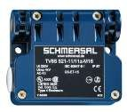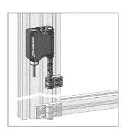
Switch
TV8S 521-02/20z
Universal joint
K1
Hinge F

Fig. 6 - Switch TV8S 521-02/20z Fig. 7 - Installation example of the switch TV8S 521-02/20z

Table 2 – Components of the door position detector

Quantity | Designation | Manufacturer's item number
1 | Switch | TV8S 521-02/20z
1 | Universal joint | K1
1 | Hinge | F

Installation example of the electric door interlocking system Schmersal AZM 415
Figures 8 and 9 show installation examples of the electric door interlocking system Schmersal AZM 415 for the wing door units FTLE (left-hinged) and FTRE (right-hinged). The holes are specified in the maker's installation instruction and shall be drilled on the site.

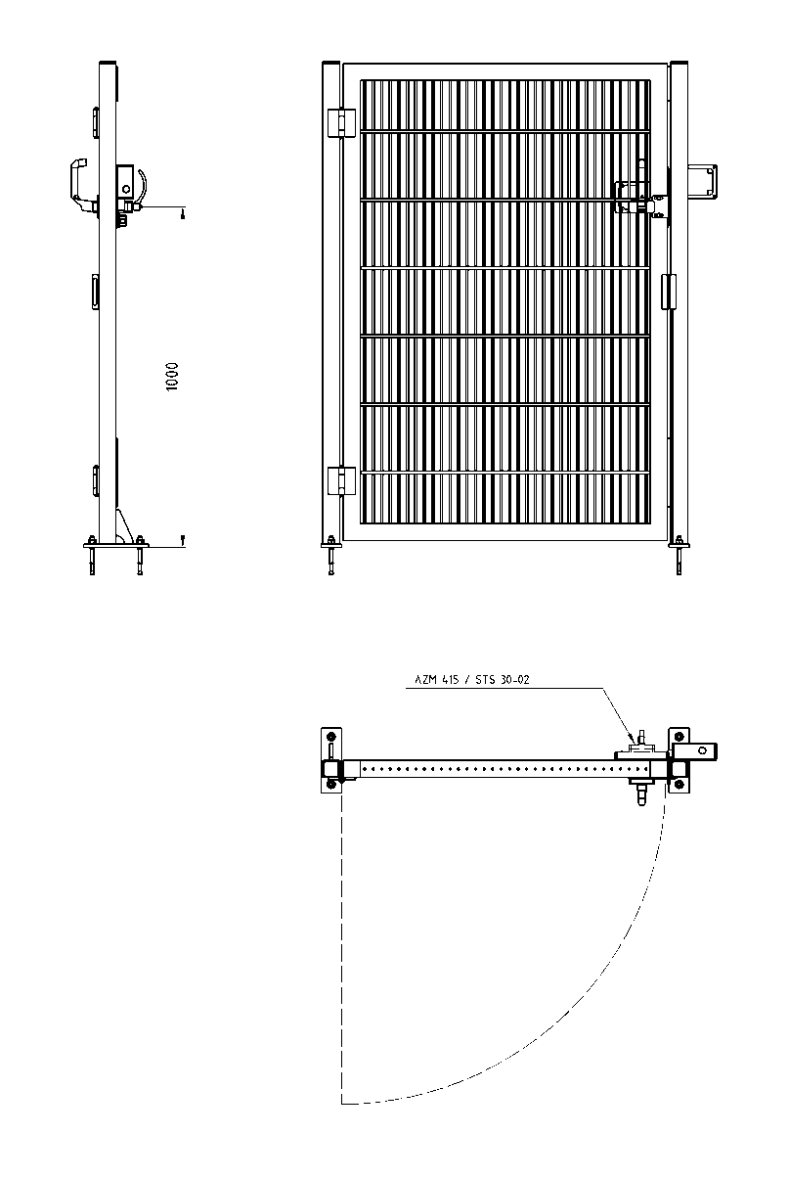
Handle system
AZM 415-STS30-02

Fig. 8 – Left door hinge

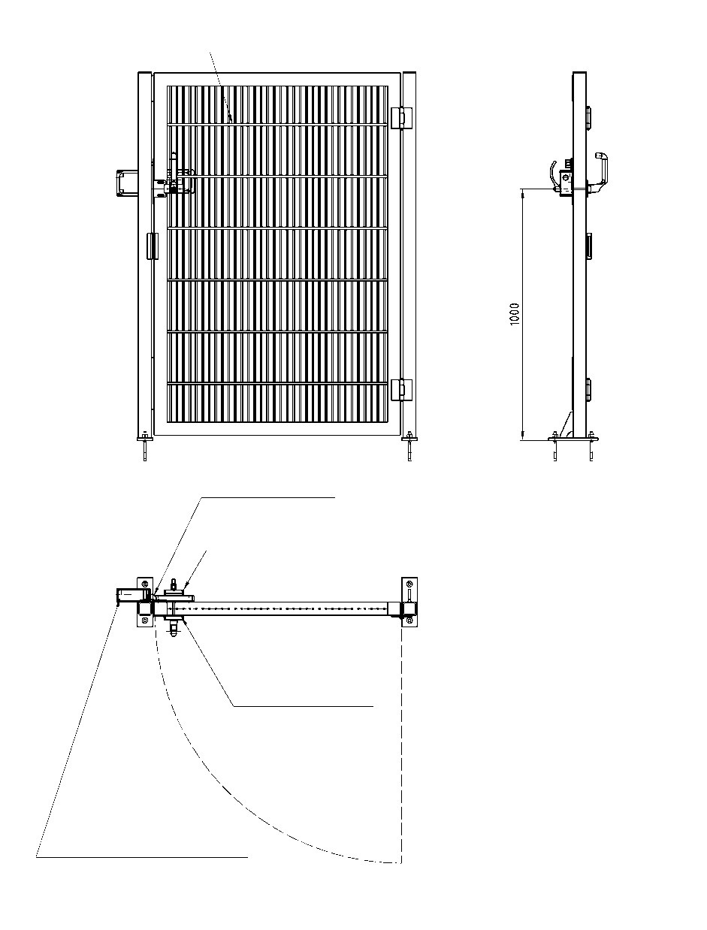
Wing door unit
SN 401-3-FTRE
Door snap
TFI-010
Handle system AZM 415-STS30-01
Mounting plate
MP TG-01
Guard lock
AZM 415-02/11zpkTEI-24VAC/DC

Fig. 9 – Right door hinge

- Key transfer system DOLD STS
To achieve performance level PL d, a key transfer system of make DOLD, type STS, shall be used. The key transfer system (figures 11 and 12) consists of the following basic modules:
    - Guard lock module (STS-YRH; STS-ZRF)
    - Switch module (STS-RX)
    - Key module (STS-01S; STS-10S)
    - Padlock module (STS-V)
    - Actuator (STS-CS/x; STS-A; STS-B)

and of the appropriate mounting components like bayonet ring, end module etc.

For various applications and plant types, assemblies consisting of these basic modules are defined and can be combined as complete units to form a key transfer system on the building block principle.

Every key transfer system shall be provided with its own coding. The doors of a danger zone are secured with an assembly for door interlocking. Every door interlock of a danger zone is provided with the same key.

Assemblies of key transfer system DOLD-STS
A list of the defined assemblies of the DOLD-STS key transfer system can be found in Annex A.

Door interlock
For door interlocking, assemblies according to Annex A, figure A.1 are used. All assemblies can be used for door hinge on the right or on the left.

Door interlock for escape unlocking
When required, an escape unlocking mechanism type STS-F-Kit shall be used which is firmly mounted to the door post inside the danger zone. This mechanism allows the actuator of the closed door interlock to be released from the door frame so that the door can be opened. This procedure is detected by switch contacts in the escape unlocking mechanism. Figure 10 shows an escape unlocking mechanism with door interlock.

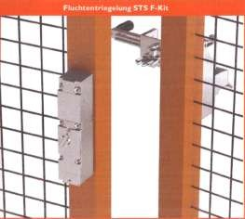Actuator

Switch module

Fig. 10 – Escape unlocking mechanism with door interlock

Key exchange box
For danger zones with two or more access doors, key exchange boxes are provided. They are made up of the defined assemblies (see 4.1) which can be expanded with one or more units of key modules (STS-01S; STS-10S) and keys.

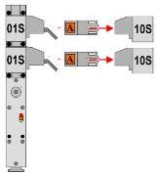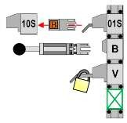Unit for expanding with one further access door.

Fig. 11 – Withdrawing of master key "A" Fig. 12 – Main access door of the danger zone

The key exchange box is arranged either in the place where the master key "A" (Fig. 11) is withdrawn or at the defined main access door of the danger zone (Figure 12).

Key module combined with guard lock module
In normal operation of the equipment, the master keys "A" are on the key modules combined with the guard lock modules and are locked there. To allow withdrawal of the key, the locking magnet is energized by the automation system.
The condition of the guard lock module is signalled to the automation system and the safe control system.
The master key "A" and the key module combined with the guard lock module are part of this standard, the design of the locking magnet is not part of this standard.

Installation of the assemblies
The assemblies are fastened to mounting plates or control cabinets (refer to Annex A, fig. A.2).

DOLD-STS switching principle
Withdrawal of master key "A" from the key module combined with the guard-lock or switching module leads to safe switching off of the danger zone equipment by the safe control system. Insertion of master key "A" in the key module combined with the actuator allows the access door to the danger zone to be opened. As an option, a number x of door keys "B" can be provided at this door and used for further access doors to the danger zone. These door keys "B" too can only be withdrawn from the corresponding key module when the door is in closed and locked condition.

Opening of the access door blocks master key "A" in the key module till the access door has been properly locked and all door keys "B" have been re-inserted in the corresponding key modules.

The STS switching principle is illustrated in figure 13.

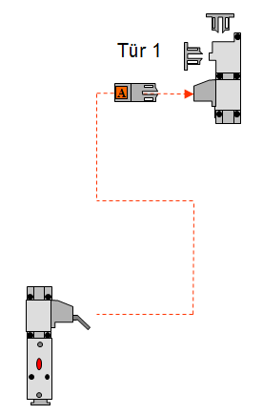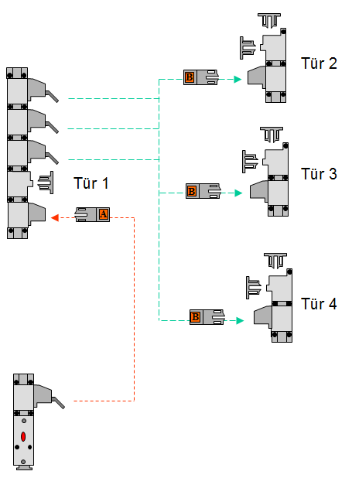
Danger zone 1
Danger zone 2

Fig. 13 – Switching principle STS for 2 danger zones

Installation example of key transfer system DOLD-STS

4.3.1 Installation example of door interlock
Figurers 14 and 15 show installation examples of the DOLD-STS key transfer system with door interlock for a swing door and for a sliding door. The positions of the holes were taken from Annex A, figure A.2; the holes shall be drilled on the site.
Figure 16 shows a detail representation of the actuator.

1750
1400
1000
40
207
266
386
506
566

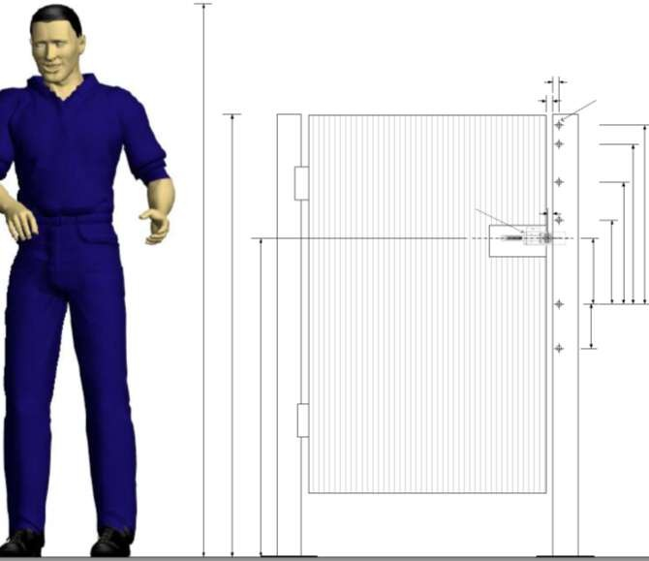Fig. 14 - Installation example of a door interlock for a swing door
20
20
each inside
thread M6
each inside thread M4
15

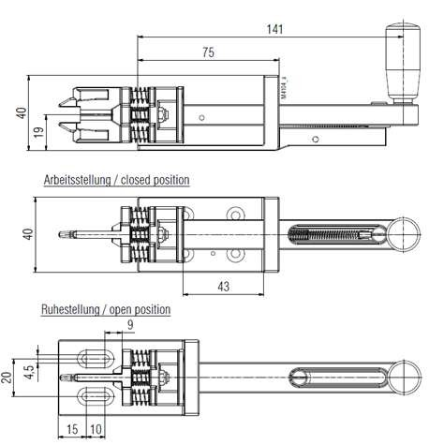

Fig. 16 - Actuator

Referenced technical standards, codes and regulations

DIN EN ISO 13849-1 Safety of machinery - Safety-related parts of control systems

Type examin- on safety concept for the design of safety-relevant control, ation certificate emergency stop and monitoring functions
MHHW 10 054

SN 401-1 Safety provisions for danger zones; Fence systems; Overview - Definitions SN 401-3 Safety provisions for danger zones; Door units and door elements

Revision of July 2013
Cancelling of electric door interlocking system of Euchner MGB.
Key transfer system Haake HST replaced with key transfer system DOLD STS. Editorial revision.

Annex A (normative)

Door interlocking system Schmersal AZM 415

Table A.1 – SAP material No. for Schmersal AZM 415 door interlock

SAP material-No. | Quantity | Designation | Manufacturer's item number
10178714 | 1 | Guard locking a) | AZM 415-02/11zpkTEI-24VAC/DC
10076683 | 1 | Handle system (right-hinged) | AZM 415-STS30-01
10076684 | 1 | Handle system (left-hinged) | AZM 415-STS30-02
10126984 | 1 | Door snap | TFI-010
10126975 | 1 | Mounting plate | MP
10076687 | 1 | Male triangular wrench b) | M5
a) Suitable for left-hinged and right-hinged doors
b) Male triangular wrench for auxiliary unlocking from outside

Table A.2 – Components of door position detector

SAP material-No. | Quantity | Designation | Manufacturer's item number
10160081 | 1 | Switch | TV8S 521-02/20z
10160082 | 1 | Universal joint | K1
10160083 | 1 | Hinge | F

Key transfer system DOLD STS - overview of assemblies

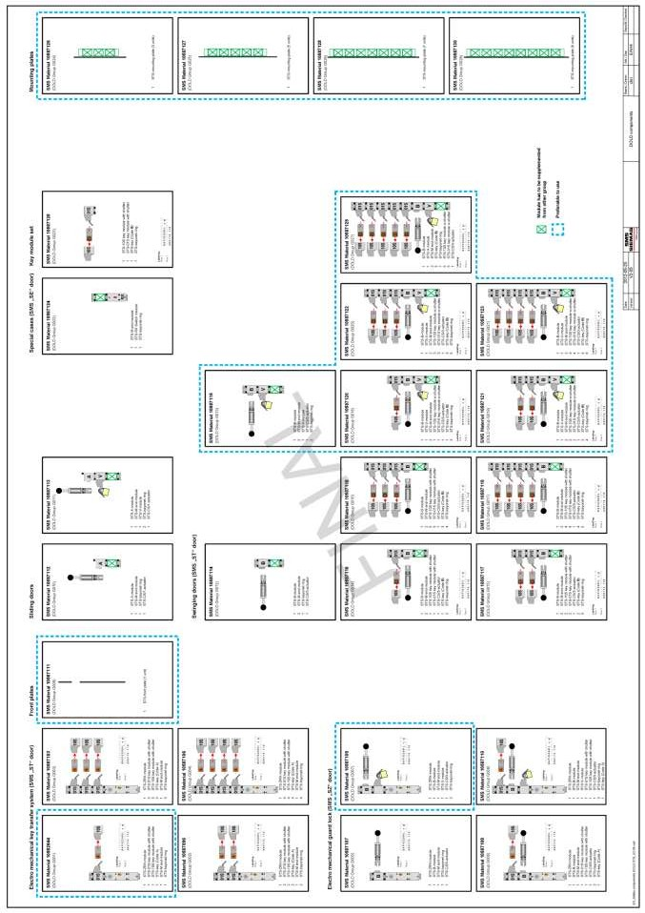

Fig. A.1 – Overview of assemblies of the key transfer system

Key transfer system DOLD STS – structure and dimensional diagrams

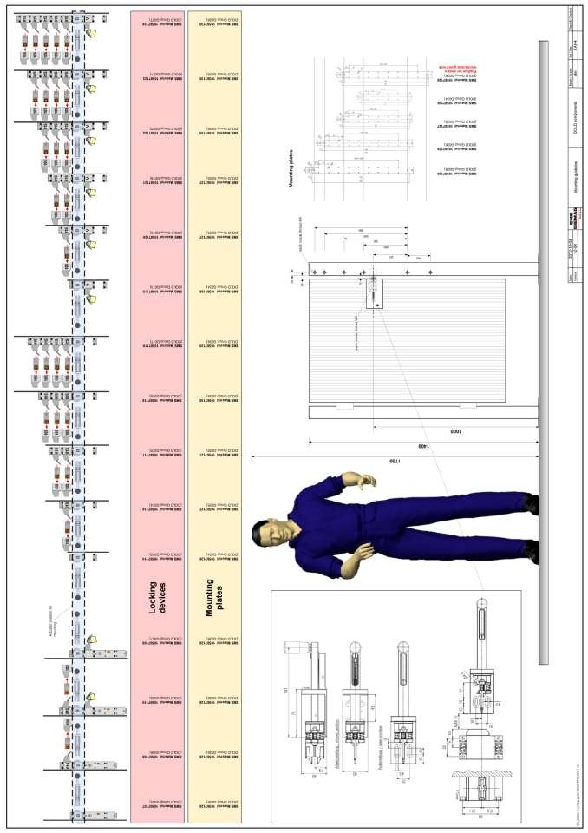

Fig. A.2 – Structure and dimensional diagrams of the key transfer system

